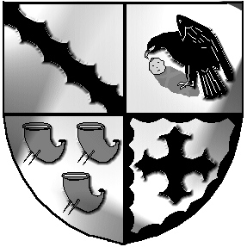
Culcheth and Glazebury Parish Council

_______________________________________________________________________________

Minutes

Planning Committee Meeting

held at 6pm on Tuesday 25th April 2023

at Glazebury Methodist Church

Councillors on Planning Committee: K Bland, P Holmes, N Johnson, and C Smith

Open and welcome 6pm

Part 1

- Councillors Apologies None

- 3.1 Code of Conduct – Declaration of Interests None
  - Localism Act 2011 – Dispensations None

- Minutes were agreed at the previous PC meeting held on 11th April 2023.

- Review applications for April
Applications were reviewed and comments agreed.

Trident comments from others

Clerkv to submit comments as agreed

- Date of the next meeting 30th May 2023

Closed 6.20pm

Meeting opens to the Public None

Part 2
Items of a confidential nature None

Signature Date

