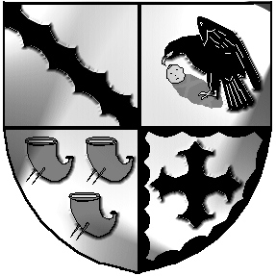
Culcheth and Glazebury Parish Council

Agenda

Parish Council Meeting

Meeting to be held at 7.30pm on Tuesday 10th October 2023

at the CULCHETH CENTRE
Councillors
Chairman K Bland Vice Chairman J Seddon
Councillors S Bland, B Alldred, P Holmes, V Allen, N Johnson, C Benson, C Smith, S Carr

PART 1 Welcome & Open
- To receive member’s apologies for unavoidable absence

- 2.1 Code of Conduct – Declaration of Interests
  - Localism Act 2011 – Dispensations

- To approve the Minutes of the Parish Council Meeting held on 12th September 2023

- Matters arising [for items not included on the agenda below]

- Police Report for September 2023 for Culcheth, Glazebury & Croft

- Planning Committee
6.1 To approve the Minutes of the Planning Committee Meeting held on 26th September 2023
6.2 Review current applications
6.3 Agree comments for submission
6.4 To approve delegation to the Clerk between meetings

- Land & Environment Committee
7.1 To approve the Minutes of the Land & Environment Committee Meeting held on 26th September 2023
7.2 Report

- Finance
8.1 To consider the grant application from the Daten for funding towards a £1700 refuse store
8.2 Clerk’s verbal report
8.3 External Audit
8.4 Review and approve payments to be made
8.5 Office
8.6 Speed indicator
8.7 Noticeboards

- Borough Councillor Report

- Correspondence

- Items for future agenda / discussion

- Chairman’s Communications

- To confirm Date & Venue of next meetings

This meeting will be closed and opened to the public.
Meeting opens to the Public

PART 2 None Tina Rogers-Smith

