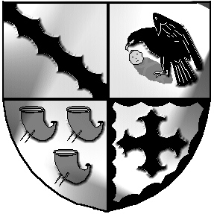
Culcheth and Glazebury Parish Council

_____________________________________________________________________________
Land and Environment Committee

Agenda

6.30pm on Tuesday 30th May 2023

at Glazebury Methodist Church

All Councillors and public are welcome to attend

Councillors on Land & Environment Committee: S Bland, Benson, Johnson, Seddon, Alldred

Open

Part 1
Present

- Elect a Committee Chairman

- Councillors Apologies

- 3.1 Code of Conduct – Declaration of Interests
3.2 Localism Act 2011 – Dispensations

- Minutes for the Land & Environment Meeting held on 25th April 2023
were agreed at the PC meeting held on the 9th May 2023.

- Law and Order
ASB

- Park

- Post office

- Items for the next meeting

Close

Meeting opens to the Public

Part 2

Items of a confidential nature None

