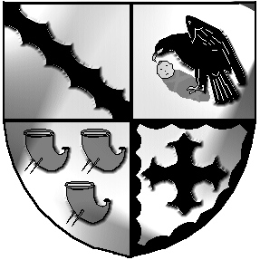
Culcheth and Glazebury Parish Council

_______________________________________________________________________________

Planning Committee

Agenda

Meeting to be held at 6pm on Tuesday 30th May 2023

at Glazebury Methodist Church

All Councillors and public are welcome to attend

Councillors on Planning Committee: K Bland, P Holmes, N Johnson, and C Smith

Open and welcome

Part 1

Present

- Elect a Committee Chairman

- Councillors Apologies

- 3.1 Code of Conduct – Declaration of Interests
  - Localism Act 2011 – Dispensations

- Minutes agreed at the previous PC meeting held on 11th April 2023.

- Review applications for May see separate list

- Date of the next meeting to be agreed

Close

Meeting opens to the Public

Part 2
Items of a confidential nature

None

