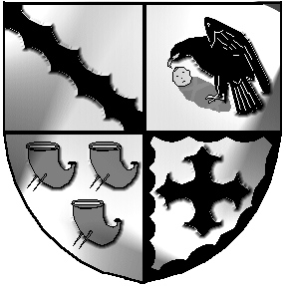
Culcheth and Glazebury Parish Council

_______________________________________________________________________________

NOTICE IS HEREBY GIVEN that the

Annual Parish Meeting APM
[Electors Meeting]

Will be held at 7pm on Tuesday 9th May 2023

At a venue to be confirmed

Glazebury Methodist Church OR the Culcheth Centre

Please check the website www.culchethandglazebury-pc.org.uk

Every year the Parish Council is required, by law to hold a ‘Parish Meeting.’ Whilst the Parish Council arrange this meeting and can provide reports upon Parish matters, it is not a meeting of the Parish Council. The Chairman of the Parish Council usually calls the meeting and chairs it. Parish Councillors do not have to attend, but if they do, they are there as members of the public. If there is a vote anyone voting must be on the electoral register for the Parish. It is, specifically, a meeting for Parish residents and Community Groups to bring up any issue, raise any questions or put forward ideas and proposals in relation to the Parish of Culcheth & Glazebury.

Open
- Welcome and introduction by the Chairman N Johnson

- Present

- Minutes of the previous APM

Resolve to agree the Minutes of the Annual Parish Meeting held on 10th May 2022 as a true and accurate record

- Matters arising

- Annual Report

- Matters raised by parish electors – Open Forum

- Thank you

Chairman

Councillor Neil Johnson

