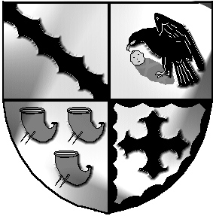
Culcheth and Glazebury Parish Council

9th March 2023

Councillors

You are hereby summoned to attend the Parish Council Meeting

to be held at 7.30pm on Tuesday 14th March 2023

at the Culcheth Centre

Tina Rogers-Smith

Clerk & RFO to Culcheth & Glazebury Parish Council

The public are welcome to attend but there is limited space, and you are advised to email the Clerk. Meetings may be recorded.

Agenda

Parish Council Meeting

Meeting to be held at 7.30pm on Tuesday 14th March 2023

at the Culcheth Centre

Councillors
Chairman N Johnson Vice Chairman K Bland
Councillors S Bland, B Alldred, P Holmes, V Allen, C Benson, C Smith, J Seddon, S Carr

PART 1 Welcome & Open
- To receive member’s apologies for unavoidable absence Cllr Smith

- 2.1 Code of Conduct – Declaration of Interests
  - Localism Act 2011 – Dispensations

- To approve the Minutes of the previous PC meeting held on 14th February 2023

- Police Report for February 2023 for Culcheth, Glazebury & Croft

- 5.1 Planning Committee Report
5.2 To approve the Minutes of the Planning Committee Meeting held on 28th February 2023
5.3 Review applications
5.4 Agree comments for submission

- 6.1 Land & Environment Committee Report
6.2 To approve the Minutes of the Land & Environment Committee Meeting held on 28th February 2023
6.3 Community Day Working Group report
6.4 Land & Environment for further discussion & future meetings

- Finance
7.1 Review and approve payments to be made
7.2 Agree supplier payment agreements for 2023/2024

- Borough Councillor Report – Cllr Allen or Cllr Benson

- Chairman’s Communications

- To confirm Date & Venue of next meeting

This meeting will be closed and opened to the public.

Meeting opens to the Public

PART 2 None

