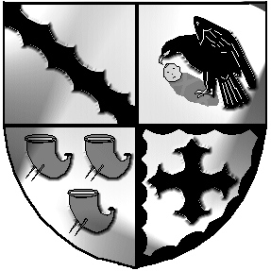
Culcheth and Glazebury Parish Council

_____________________________________________________________________________

Land and Environment Committee

Agenda

7pm on Tuesday 30th August 2022 at Culcheth Library

Councillors on Land & Environment Committee: S Bland, Benson, Johnson, Seddon, Alldred

Open

Part 1

- Councillors Present

- Councillors Apologies

- 3.1 Code of Conduct – Declaration of Interests
  - Localism Act 2011 – Dispensations

- Minutes of the previous meeting held on 26th July 2022

- Law and Order

- Millenium Garden

- Christmas Market

- Defibrillators

- Culcheth Play Area

- Park - Kick rail

- Weeds etc

- WBC Land at Hampson Avenue / Warrington Road

- Glazebury Garden

- Linear Park

- Garden contract

- Date of next meeting

Close

Meeting opens to the Public

Part 2

Items of a confidential nature
None

