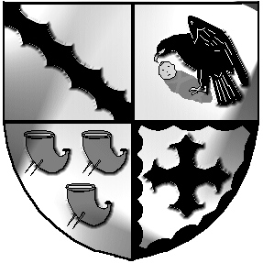
Culcheth and Glazebury Parish Council

_______________________________________________________________________________

Planning Committee

Minutes

Of the Meeting held at 6.30pm on Tuesday 29th March 2022

at Culcheth Library
Opened at 6.30pm

Part 1

- Councillors Present
Chair Cllr Holmes
Councillors Bland, Johnson, Smith

- Councillors Apologies None

- 3.1 Code of Conduct – Declaration of Interests None
  - Localism Act 2011 – Dispensations None

- Minutes of the previous meeting were agreed at the full PC Meeting on 8th March.

- Review applications for March
Cllr Holmes had identified some applications for which comments had not been submitted. The Clerk responded on some queries and will follow up on urgent responses needed. The approach had been working well but has gone off course a little. Councillors agreed on how to move forward.

Clerk to submit comments agreed

- Correspondence has been forwarded to Councillors from WBC regarding planning & enforcements.

- Individual Councillor Report None

- Items not included above None

11 Date of the next meeting 6.30pm on Tuesday 26th April at Culcheth Library

Closed 6.55pm

Meeting opens to the Public
None present

Part 2
Items of a confidential nature None

Signed Date

