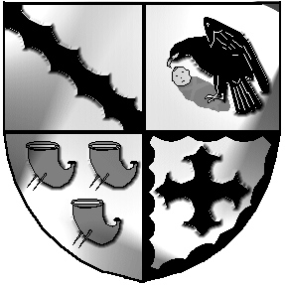
Culcheth and Glazebury Parish Council

_______________________________________________________________________________

Planning Committee

Agenda

Meeting to be held at 6pm on Tuesday 26th October 2021 at Culcheth Library

To: Councillors K Bland, P Holmes, N Johnson, and C Smith

Open

Part 1

- Councillors Present

- Councillors Apologies

- 3.1 Code of Conduct – Declaration of Interests
  - Localism Act 2011 – Dispensations

- Minutes of the previous meeting to be agreed

- Matters Arising

- Review applications for October

- Local Plan

- Correspondence
WBC Planning applications, enforcements etc

- Individual Councillor Report [for items not covered above]

- Items not included above

11 Date of the next meeting

Close

Meeting opens to the Public

Part 2
Items of a confidential nature
Tina Rogers-Smith
Clerk & RFO
19/10/2021

