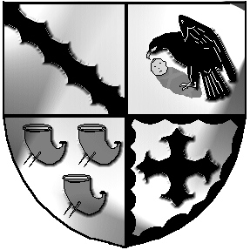
Culcheth and Glazebury Parish Council

MINUTES
Of the EXTRAORDINARY PARISH COUNCIL MEETING
Held at 10.30am on Friday 13th August 2021
At Culcheth Library
Opened 10.30am
PART 1
- Present: Chairman Cllr B Alldred
Councillors: K Bland, N Johnson, C Benson, C Smith, J Seddon
Clerk Tina Rogers-Smith

- Apologies for unavoidable absence
Councillors: S Bland, Holmes, Allen, Benson

- 3.1 Code of Conduct – Declaration of Interests
Members are reminded of their responsibility to declare any personal interest or prejudicial interest which they have in any item of business on the agenda as soon as they become aware of that interest. None

3.2 Localism Act 2011 – Dispensations
Members are reminded of their responsibility to make a request for a dispensation to speak on any matter for which they have declared an interest. None

- Finance – to approve payments for August
Councillors discussed accounts for payment.
Proposed by Cllr Bland Seconded by Cllr Alldred Agreed by all

Resolved that the accounts for August be approved for payment. Agreed by all.

- Planning Applications
Councillors discussed applications

Clerk to submit comments as directed
- AOB - none

- To confirm Date and Venue of Next Meeting
Tuesday September 14th venue to be confirmed

Public Forum none in attendance
PART 2 None

SIGNATURE DATE

