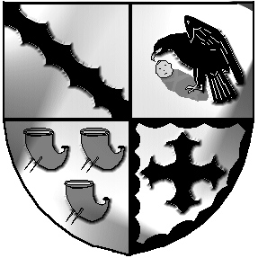
Culcheth and Glazebury Parish Council

_______________________________________________________________________________

Planning Committee

Agenda

Meeting to be held at 6pm on Tuesday 28th September 2021 at Culcheth Library

To: Councillors K Bland, P Holmes, N Johnson and C Smith

- Councillors Present

- Councillors Apologies

- Minutes of the previous meeting to be agreed

- Matters Arising

- Review applications for September

- Training
[i] CHALC
[II] WBC

- Correspondence
WBC Planning applications, enforcements etc

8 Individual Councillor Report [for items not covered above]

9 Date of the next meeting

Close of meeting.

Meeting opens to the Public

