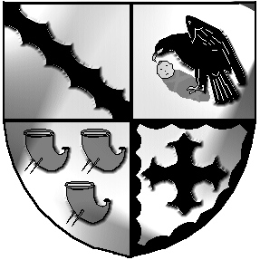
Culcheth and Glazebury Parish Council

_______________________________________________________________________________

Annual Parish Council Meeting APCM Number 15

Agenda

Meeting to be held at 7.30pm on Monday 17th May 2021

At the Culcheth Centre

Police Report
PART 1

Opening

  - Code of Conduct – Declaration of Interests
Members are reminded of their responsibility to declare any personal interest or prejudicial interest which they have in any item of business on the agenda as soon as they become aware of that interest.

1.2 Localism Act 2011 – Dispensations
Members are reminded of their responsibility to make a request for a dispensation to speak on any matter for which they have declared an interest.

- To receive member’s apologies for unavoidable absence

- To Elect a Chairman for 2021/2022

- To Elect a Deputy Chairman for 2021/2022

- To appoint members to the Finance Sub Committee

- To appoint members to the Planning Sub Committee

- To appoint members to the Land & Environment Sub Committee

- To appoint members to the Risk Assessment Sub Committee

- To appoint members to the Staffing Sub Committee

- To approve the Minutes of Meeting Number 14 held on 13th April 2021

- Matters Arising
All items related to Planning, Land & Environment, Finance to be in items 13, 14 and 15.

- To receive a Borough Council report

- To receive a report from the Planning Sub Committee
& to approve the minutes of the meeting held on 27th April 2021

- To receive a report from the Planning Sub Committee
& to approve the minutes of the meeting held on 27th April 2021

- Finance

  - Applications for Financial Assistance

  - To approve accounts for payment for May 2021

- End of Year Accounts [Governance Statement of Accounts] 2020/2021

- End of Year Accounts [Statement of Accounts] 2020/2021

- Asset Register

- Chairman’s Allowance

- External Audit

- Internal Audit

- Documentation Review

- Correspondence

- Chairman’s communications

- Other Business

- To confirm Date & Venue of next meeting

This meeting will be closed and opened to the public.

Meeting opens to the Public

