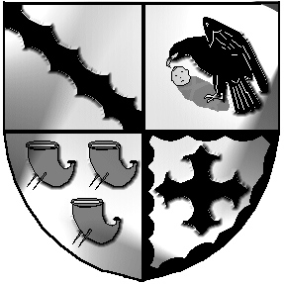
Culcheth and Glazebury Parish Council

_______________________________________________________________________________

Land and Environment Committee

Agenda

Tuesday 27th July 2021 at 7pm at Culcheth Library

To Councillors C Benson, S Bland, N Johnson, J Seddon, C Smith and P Holmes

- Councillors Present

- Councillors Apologies

- Minutes of the previous meeting held on 22nd June 2021 were agreed at the
Parish Council Meeting on 13th July 2021.

- Matters arising
Shaw Street car park
Skate park
Round seats
Glazebury Garden
Glazebury Play Area
Road Signs

- Neighbourhood/Community reports

- Law and Order issues

- Correspondence
WBC various
Public - re door stickers
Public – Shaw Street
Public – website
Public - Thank you for moving planter

- Individual Councillor Reports [ for items not covered above]

- Date of next meeting

Close of meeting.

Meeting opens to the Public

