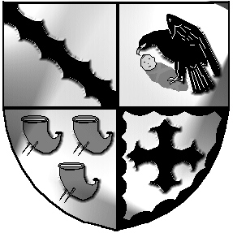
Culcheth and Glazebury Parish Council

Parish Council Meeting

Meeting to be held at 7.30pm on Tuesday 13th July 2021

At the Culcheth Centre
Police Report
PART 1

Opening

  - Code of Conduct – Declaration of Interest
1.2 Localism Act 2011 – Dispensations

- To receive member’s apologies for unavoidable absence

- To approve the Minutes of Meeting held on 8th June 2021

- Matters Arising
[i] Shaw Street car park
[ii] Glazebury Gardens
[iii]Hampson Avenue triangle

- To receive a Borough Council report

- To receive a report from the Planning Sub Committee
& to approve the minutes of the meeting held on 29th June 2021

- To receive a report from the Land & Environment Sub Committee
& to approve the minutes of the meeting held on 29th June 2021

- Finance
  - Applications for Financial Assistance
  - To approve accounts for payment for June 2021
  - Financial regulations and Financial Risk Assessment
  - End of Year Accounts [Governance Statement of Accounts & Statement of Accounts] 2020/2021 to approve and sign
  - Internal and External Audits
  - Signature

- Correspondence

- Chairman’s communications

- Individual Councillor Reports

- To confirm Date & Venue of next meeting

Meeting opens to the Public

Part 2

Clerk review

