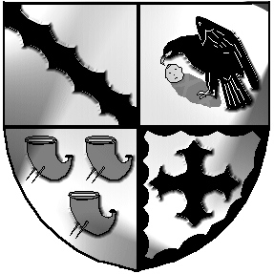
Culcheth and Glazebury Parish Council

Clerk to the Council: Mr M. Durrington,
Culcheth Library
Warrington Road, Culcheth.
WA3 5SL
Phone: 01925 - 733619 Email: culcheth.clerk@btinternet.com
Web: culchethandglazebury-pc.org.uk

5th May 2020 - Parish Council Meeting
You are invited to attend a meeting of the Parish Council which is to be held at 7.30 pm on Tuesday 12th May 2020 to conduct the business detailed herewith. This meeting to conducted via Zoom video conferencing. If you wish to attend please email the Clerk.

Mr. M Durrington

Clerk to the Parish Council

AGENDA

Police Report

Items for consideration to be discussed in the presence of the press and public

- Opening

2. To receive member’s apologies for unavoidable absence

3. To Elect a Council Chairman and Deputy Chairman for 2020-2021

4. To agree Dates and Times of Parish Council Meetings, appoint sub-committee members, and Confirm Appointments to Outside Bodies for 2020 -2021

5. Minutes of Meeting Number 3

6 To receive a Borough Council report

7 To receive reports from Sub-Committees

8 Applications for Financial Assistance

9 To approve accounts for payment for May 2020

10 Chairman’s Communications

11 To confirm Date and Venue of Next Meeting - 9th June 2020

To close the meeting and open to the public

